

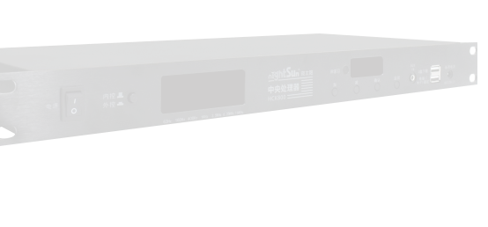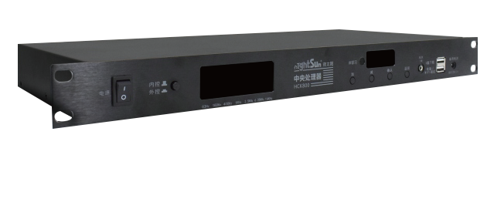

**HCK800**

**Central Processing Unit**

DMX512 input: conﬁgure two card nong input interface, connect

dimmer output, support 1024 channels.

The dimming input: XLR * 1 x input dimming DMX512 signal,

Make a record and edit again to meet more applications

DMX512 output: conﬁgure two card nong and two front-end

ports output interface, support 1024 channels.

Inside and outside of switch: external control status to external light direct control, internal control status for running the acousto-optic linkage eﬀect automatically.

Dimmer learning: programming can learn to record the dimming, you do not need to manually pull plug lines when learning intelligent switch.

Back insert audio testing priority: ﬁber SPDIF digital audio input RCA input, 3.5 AUX and stereo headphones.

Rhythm acousto-optic linkage: built-in audio frequency analysis module, the light and music perfect cooperation.

Song audible and visible linkage: linkage linkage point song song classiﬁcation of the scene.

Dynamic spectrum of LED visual display the current audio spectrum.

Computer debug software: HCK800S 1024 computer software

that move light Wireless debugging: connect the external WIFI box, debug parameter download wireless implementation eﬀect.

External control function: special circumstances can control external acoustics, air conditioning, door system, etc.

Engineering management: user permissions Settings, all the Settings and eﬀects can be saved to a computer for backup.

U disk function: through the usb upgrade program, download parameters, update the wiring ,upgrade the trouble of a solution. Input/working voltage: AC ~ 220 v / 50 to 60 hz machine power consumption: 2 w or less ; standby power D C: 12V/ 1A, convenient debugging

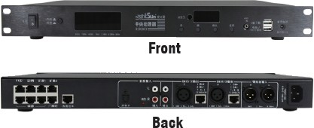

Front

Back

The external power supply: through RJ45 port, to provide DC12V / 1 a power supply, including wallboard, extension, 1/2, junction box

# DMX512 output: XLR * 1, RJ45 * 1102 4 channels Audio detection: RCA * 2 input, RCA * 2 loop output

Power ampliﬁer infrared: Rj45 interface, provide special infrared emission head, cable connection

VOD :connect each jukebox RJ45 interface, through the connection box

Air conditioning: connect wiring achieve infrared and RS485 control air conditioning

Wall Street lamp: RJ45 interface, RS485 communication, adopting RS485 bus control protocol

The extended 1/2:RJ45 interface, RS485 communication, set asi de other extensions

The IR receiver window: built-in infrared receiving head, learning infrared code value

NIGHTSUN PROFESSIONAL LIGHTING PROVIDER.