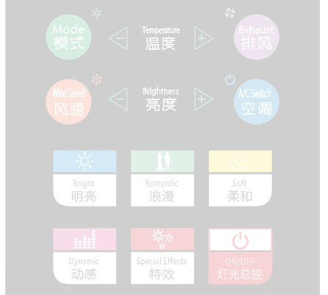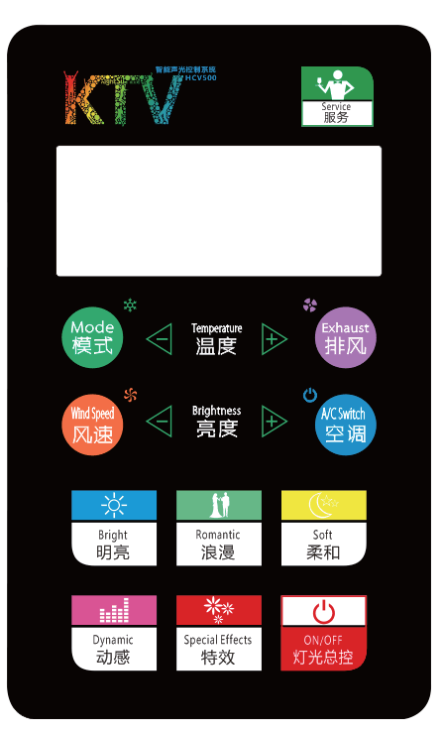

**HCV500**

**Service Intelligence Board**

**(Vertical Screen)**

Dimensions Size：190(L）*118(W)*10(D)mm

Touch Mode: Capacitive

Backlight: Independent backlight indication of the lighting scene Number of Buttons: 16

Panel Material: Tempered glass Frame Material: Zinc alloy

Net Weight: 0.5KG

Installation Method: Standard 86 bottom box

NIGHTSUN PROFESSIONAL LIGHTING PROVIDER.